PeopleSoft Data Extractor

**User Guide**

# Document Revisions

|  |  |  |  |
| --- | --- | --- | --- |
| **Date** | **Version** | **Document Changes** | **Author** |
| 01/13/2016 | 1.0 | Initial Draft | Sumit Chaurasiya |
| 01/15/2016 | 1.1 | Added screenshots | Sumit Chaurasiya |
| 01/28/2016 | 1.2 | Renamed Applicant to Pre-hire. Added Support contact email-id for project manager. Also added description of the folders in the package. | Sumit Chaurasiya |
| 04/07/2016 | 1.3 | Updated as per new development | Sumit Chaurasiya |
| 06/24/2016 | 1.4 | Updated as per new development | Sumit Chaurasiya |
|  |  |  |  |
|  |  |  |  |
|  |  |  |  |

**Table of Contents**

**Document Revisions**

**Introduction**

Purpose

Scope and Assumptions

System Organization

Describing the System

Key Features

Technical Inventory (PeopleSoft Objects)

Environment

**Installation**

Access Control

Steps for installing the tool

Step by Step installation procedure

Step-1: Import the Project

Step-2: Build the tables

Step-3: Run DMS import scripts

Step-4: Clear the App Server and Web Server cache

Step-5: Copy SQR files in the PeopleSoft system SQR folder

Step-6: Set the password for the output files

**Step by Step Instructions for using the system**

Running the SQR Process

**Conventions**

**Errors, Malfunctions, and Emergencies**

**Messages**

**Appendix A – Reference Documents**

**Appendix B – Glossary of Terms**

# Introduction

For the customers who are moving from PeopleSoft to Workday, there is a need to migrate the relevant data correctly and accurately to the new system with minimal effort and ease.

## Purpose

The *PeopleSoft Data Extractor* tool serves the purpose of data extraction with provisions for monitor and control of the extraction process. The tool reads the data from the PeopleSoft system and generates data files in human readable and understandable format. These files follow a standard Data Gathering Workbook (DGW) template format, ready to be consumed by Workday.

## Scope and Assumptions

1. The tool is designed to extract ONLY the data as per [Appirio standard DGW](https://docs.google.com/spreadsheets/d/1EMByVN_sxr_X3l12IGdo7L2-7BL6lNHTKfAqwWsCHT0/edit?usp=sharing).
2. The tool DOES NOT modify or change the customer’s data in any way.
3. The extracted data is in the form of XML files which can be opened in MS Excel.
4. The tool is developed and tested on PeopleSoft HCM 9.1 and Peopletools 8.53.13 and should work just fine on PS HCM 8.9 and higher and PT 8.46x and higher.
5. To install the tool, the PS Admin needs to import the package, execute the DMS import scripts and copy the SQRs in the appropriate SQR folder on customer system.
6. The output files generated by the tool will have a password which can be setup in the custom configuration PeopleSoft page designed by Appirio.
7. This package doesn’t incorporate PeopleSoft Security by Department tree/ Row Level Security since SQR code is used which extracts the data directly from database and hence doesn’t need joins with PS Security Tables. However, it’s assumed that PS Admin in user’s Organization will have full data access to query and report this data from database for validation purposes.

## System Organization

The *PeopleSoft Data Extractor* tool is packaged into

* App Designer project
* Data Mover scripts
* SQR/SQC files

The project creates Menus of its own with relevant component links to execute the custom SQR process and generating the output files in the desired format.

## Describing the System

The *PeopleSoft Data Extractor* tool contains menus, component links, a run control page and a configuration page created in the main menu after installation. The SQR process is run from the run control page and can be monitored in the process monitor. The successful run of a process generates the relevant SQR file in the customer system. The same can be readily accessed from the Process Monitor logs itself for inspection and review. The format of these files conforms the Appirio owned Data Gathering Workbook format for loading data into Workday.

## Key Features

* No need to write complex SQL queries
* Performance and data accuracy
* Compatible with Oracle database
* Ease of use (Can be operated from within PIA) for iterative data extractions
* Monitor and control by the customer

## Technical Inventory (PeopleSoft Objects)

|  |  |  |  |  |  |
| --- | --- | --- | --- | --- | --- |
| **PS Object** | **Object Type** | **Object Sub Type** | **Object Name** | **Fieldname** | **Event** |
| **Field** | Field | Char | AP_PLAN_TYPE |  |  |
|  | Field | Char | AP_SELECT11 |  |  |
|  | Field | Char | AP_SELECT12 |  |  |
|  | Field | Char | AP_SELECT13 |  |  |
|  | Field | Char | AP_SELECT14 |  |  |
|  | Field | Char | AP_SELECT15 |  |  |
|  | Field | Char | AP_SELECT16 |  |  |
|  | Field | Char | AP_SELECT17 |  |  |
|  | Field | Char | AP_SELECT18 |  |  |
|  | Field | Char | AP_SELECT19 |  |  |
|  | Field | Char | AP_SELECT20 |  |  |
| **Record** | Table |  | AP_COUNTRY_MAPS | COUNTRY |  |
|  |  |  |  | COUNTRY_2CHAR |  |
|  |  |  |  | COUNTRY_CODE |  |
|  |  |  |  | CURRENCY_CD |  |
|  |  |  |  | DESCR50 |  |
|  | Table |  | AP_SQR_SYSTEM | CNFPASSWORD |  |
|  |  |  |  | PASSWORD2 |  |
|  |  |  |  | PSIMAGEVER |  |
|  |  |  |  | FILE_DATA_JPG |  |
|  | Table |  | AP_SQR_PRCS_TBL | OPRID |  |
|  |  |  |  | RUN_CNTL_ID |  |
|  |  |  |  | SELECT1 |  |
|  |  |  |  | SELECT2 |  |
|  |  |  |  | SELECT3 |  |
|  |  |  |  | SELECT4 |  |
|  |  |  |  | SELECT5 |  |
|  |  |  |  | SELECT6 |  |
|  |  |  |  | SELECT7 |  |
|  |  |  |  | SELECT8 |  |
|  |  |  |  | SELECT9 |  |
|  |  |  |  | SELECT10 |  |
|  |  |  |  | AP_SELECT11 |  |
|  |  |  |  | AP_SELECT12 |  |
|  |  |  |  | AP_SELECT13 |  |
|  |  |  |  | AP_SELECT14 |  |
|  |  |  |  | AP_SELECT15 |  |
|  |  |  |  | AP_SELECT16 |  |
|  |  |  |  | AP_SELECT17 |  |
|  |  |  |  | AP_SELECT18 |  |
|  |  |  |  | AP_SELECT19 |  |
|  |  |  |  | AP_SELECT20 |  |
|  |  |  |  | SELECT_ALL |  |
|  | Table |  | AP_COMP_EFFDT | EFFDT |  |
|  |  |  |  | EFF_STATUS |  |
|  | Table |  | AP_COMP_CONFIG | EFFDT |  |
|  |  |  |  | AP_PLAN_TYPE |  |
|  | Table |  | AP_COMP_PLAN | EFFDT |  |
|  |  |  |  | AP_PLAN_TYPE |  |
|  |  |  |  | COMP_RATECD |  |
| **PeopleCode** |  |  |  |  | AP_SQR_SYSTEM.CNFPASSWORD.SaveEdit |
|  |  |  |  |  | AP_SQR_SYSTEM.PASSWORD2.FieldEdit |
|  |  |  |  |  | AP_SQR_SYSTEM.FILE_DATA_JPG.FieldChange |
|  |  |  |  |  | AP_SQR_PRCS_TBL.OPRID.SearchInit |
|  |  |  |  |  | AP_SQR_PRCS_TBL.SELECT1.FieldChange |
|  |  |  |  |  | AP_SQR_PRCS_TBL.SELECT2.FieldChange |
|  |  |  |  |  | AP_SQR_PRCS_TBL.SELECT3.FieldChange |
|  |  |  |  |  | AP_SQR_PRCS_TBL.SELECT4.FieldChange |
|  |  |  |  |  | AP_SQR_PRCS_TBL.SELECT5.FieldChange |
|  |  |  |  |  | AP_SQR_PRCS_TBL.SELECT6.FieldChange |
|  |  |  |  |  | AP_SQR_PRCS_TBL.SELECT7.FieldChange |
|  |  |  |  |  | AP_SQR_PRCS_TBL.SELECT8.FieldChange |
|  |  |  |  |  | AP_SQR_PRCS_TBL.SELECT9.FieldChange |
|  |  |  |  |  | AP_SQR_PRCS_TBL.SELECT10.FieldChange |
|  |  |  |  |  | AP_SQR_PRCS_TBL.AP_SELECT11.FieldChange |
|  |  |  |  |  | AP_SQR_PRCS_TBL.AP_SELECT12.FieldChange |
|  |  |  |  |  | AP_SQR_PRCS_TBL.AP_SELECT13.FieldChange |
|  |  |  |  |  | AP_SQR_PRCS_TBL.AP_SELECT14.FieldChange |
|  |  |  |  |  | AP_SQR_PRCS_TBL.AP_SELECT15.FieldChange |
|  |  |  |  |  | AP_SQR_PRCS_TBL.AP_SELECT16.FieldChange |
|  |  |  |  |  | AP_SQR_PRCS_TBL.AP_SELECT17.FieldChange |
|  |  |  |  |  | AP_SQR_PRCS_TBL.AP_SELECT18.FieldChange |
|  |  |  |  |  | AP_SQR_PRCS_TBL.AP_SELECT19.FieldChange |
|  |  |  |  |  | AP_SQR_PRCS_TBL.AP_SELECT20.FieldChange |
|  |  |  |  |  | AP_SQR_PRCS_TBL.SELECT_ALL.FieldChange |
|  |  |  |  |  | AP_SQR_PRCS_TBL.SELECT_ALL.FieldFormula |
|  |  |  |  |  | AP_COMP_CONFIG.COMP_RATECD.FieldEdit |
|  |  |  |  |  | AP_COMP_CONFIG.AP_PLAN_TYPE.FieldEdit |
|  |  |  |  |  | AP_SQR_SYSTEM_PG.Activate |
| **Pages** |  |  | AP_COUNTRY_MAPS |  |  |
|  |  |  | AP_SQR_PRCS_PG |  |  |
|  |  |  | AP_SQR_SYSTEM_PG |  |  |
|  |  |  | AP_COMP_CONFIG |  |  |
| **Component** |  |  | AP_SQR_PRCS_CMP |  |  |
|  |  |  | AP_SQR_SYSTEM_CMP |  |  |
| **Menu** |  |  | AP_SQR_PRCS_MNU |  |  |
| **Processes** | SQR Report |  | AP_PSDE |  |  |
| **Permission List** |  |  | AP_PEOPLESOFT_  DATA_EXTRACTOR |  |  |
| **Portal Registry**  **Structures** | Content reference | Portal Name: EMPLOYEE | AP_SQR_PRCS_CMP_GBL |  |  |
|  | Content reference | Portal Name: EMPLOYEE | AP_SQR_SYSTEM_CMP_GBL |  |  |
|  | Folder | Portal Name: EMPLOYEE | APPIRIO_PS |  |  |
| **Message Catalog** | Message Set Number |  | 25500 |  |  |
| **Translate Values** |  |  | A | AP_PLAN_TYPE |  |
|  |  |  | B | AP_PLAN_TYPE |  |
|  |  |  | C | AP_PLAN_TYPE |  |
|  |  |  | M | AP_PLAN_TYPE |  |

## Environment

* PeopleSoft HCM 8.9 and higher
* PeopleTools 8.46 and higher
* Oracle database

# Installation

It is advised to install the tool ONLY in Non-Production systems as a precaution.

## Access Control

The PeopleSoft Data Extractor tool is accessible only by **PS Superuser** or **PS Administrator**.

## Steps for installing the tool

The installation consists of 6 steps:

1. Import the project using Application Designer
2. Build the tables
3. Import the DMS script using Data Mover
4. Clear the App Server and Web Server cache to reflect the newly added menu/links
5. Copy the SQR/SQC files into the SQR directory used by the system
6. Set the password for the output files that will be generated by SQR process

## Step by Step installation procedure

### Step-1: Import the Project

1. Go to below mentioned link.

<https://drive.google.com/folderview?id=0B_8gN_ucZ8JySkZGTkpKa1ZwMm8&usp=sharing>

You will find :

AP_SQR_PRCS_PRJ.zip *[This zipped file contains App Designer project]*

Import Script.dms *[This contains Import Data Mover Script]*

Export Script.dms *[This contains Export Data Mover Script]*

AP_SETUP_DATA.DAT *[This contains Configurations data]*

1. Download & Extract the compressed project file (*AP_SQR_PRCS_PRJ.zip*) into a temporary designated folder. Login to Application Designer with Userid having **PS Admin** or **Superuser privileges**. The database name and Userid could be different for you.

**Figure 1**

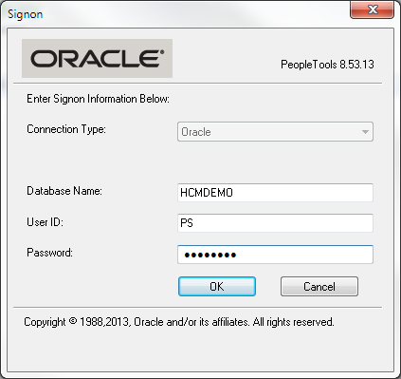

1. Navigate to Tools > Compare and Report > From File.

**Figure 2**

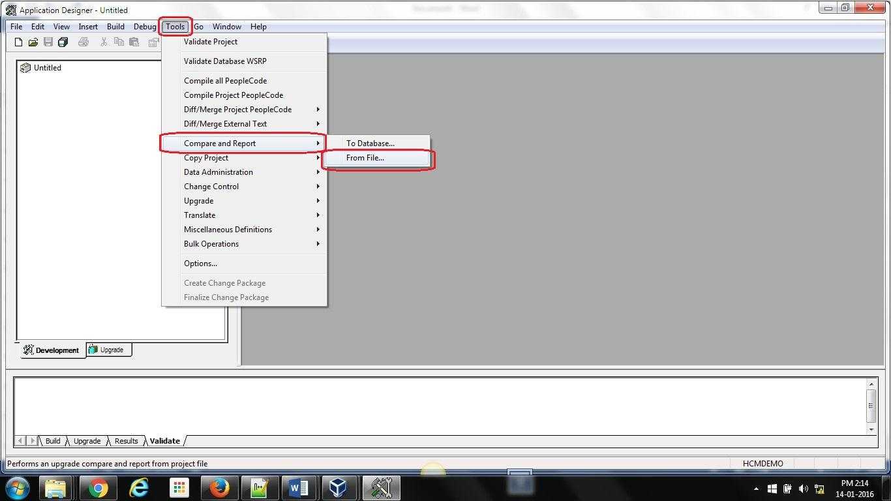

1. Choose the folder in which the project was extracted in step 2. Click on select.

**Figure 3**

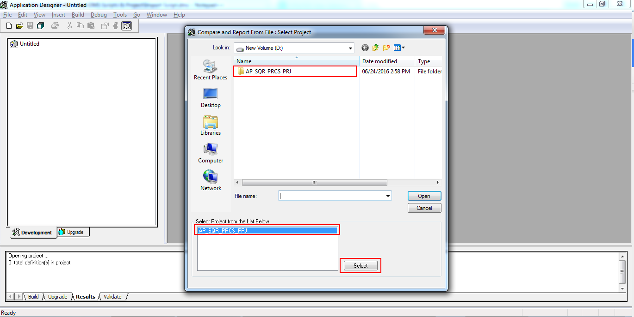

1. Click *Options* to select the compare criteria

**Figure 4**

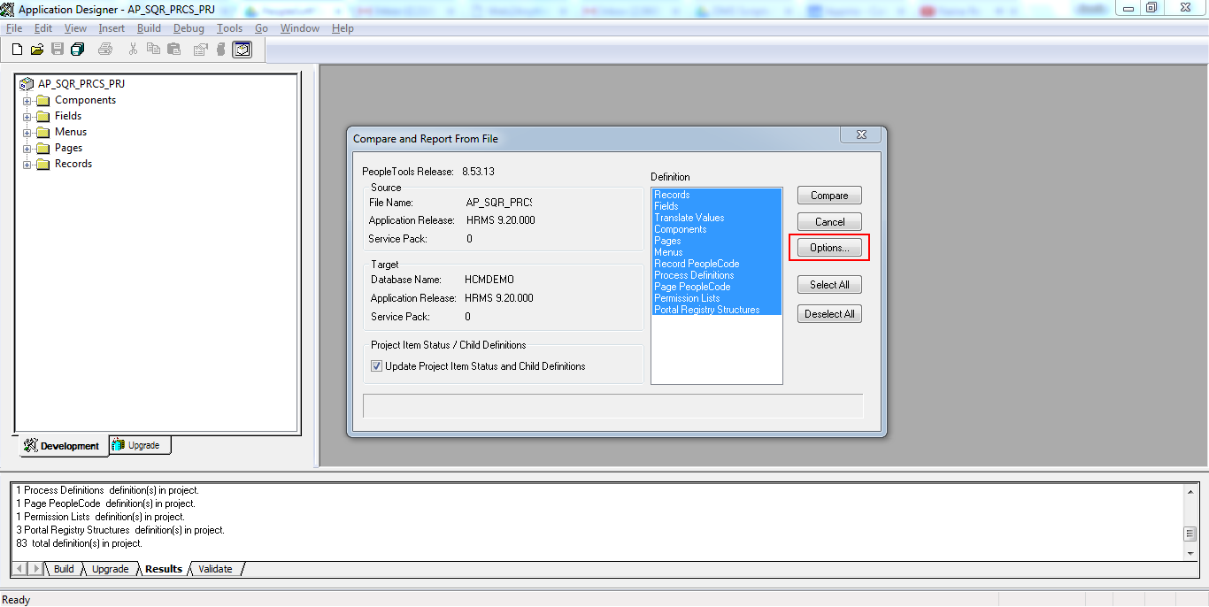

1. Click “*Select All*” in the *Report Filter* tab and click *OK*

**Figure 5**

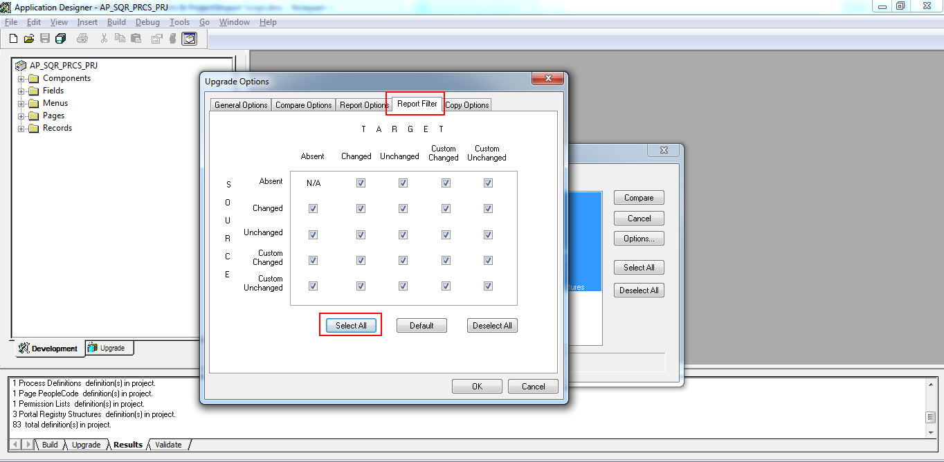

1. Click *Compare* button

**Figure 6**

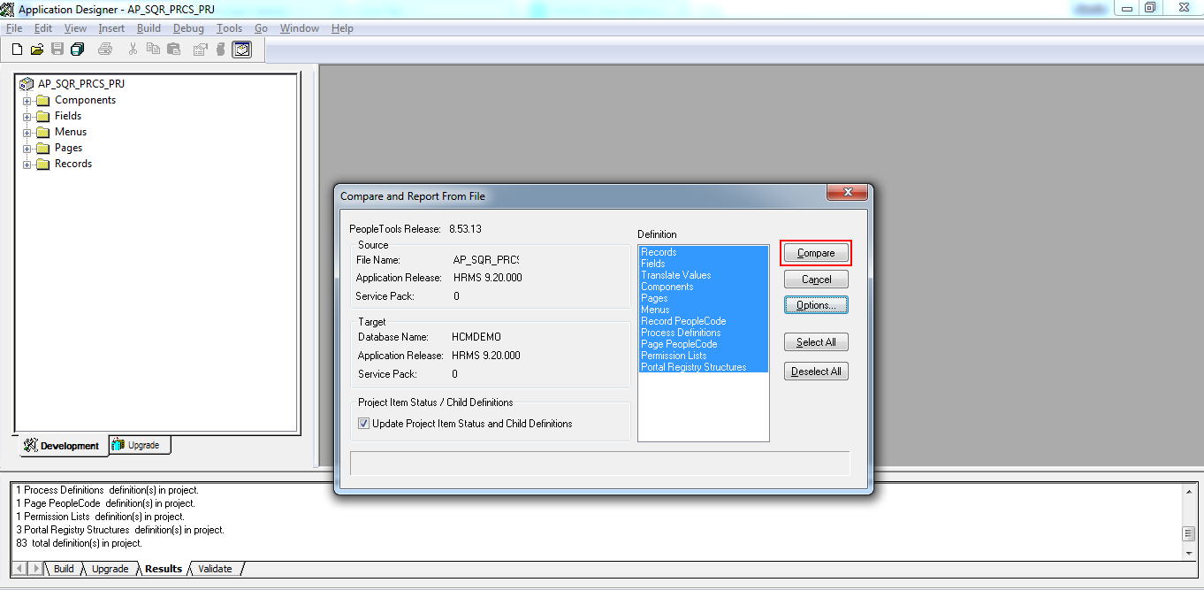

**Figure 7**

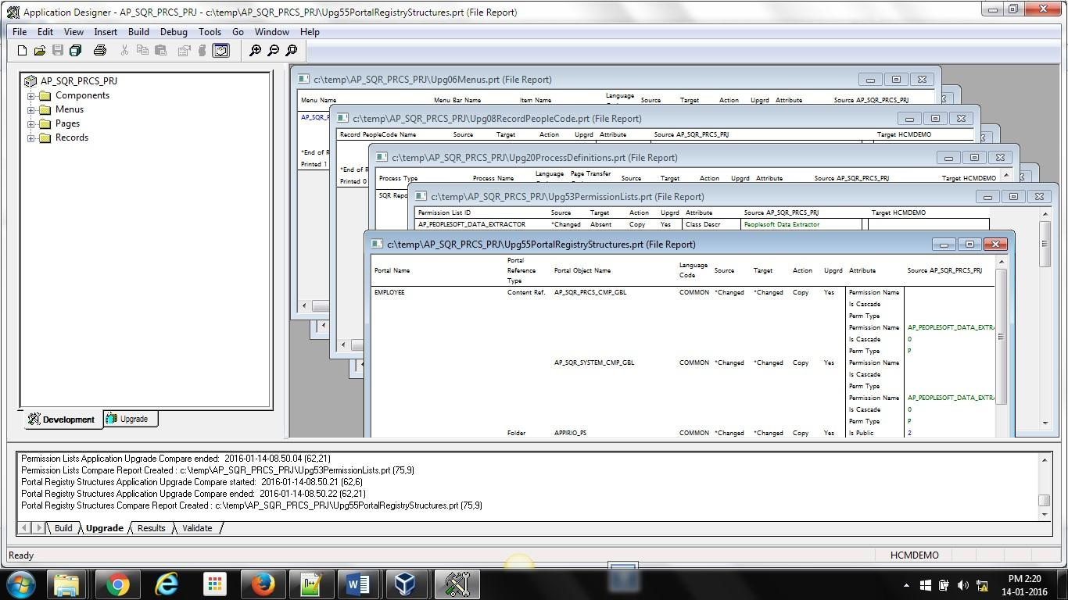

1. In *Upgrade* tab, verify the *Action* flags is set to Copy and *Upgrade* flag is checked for each report

**Figure 8**

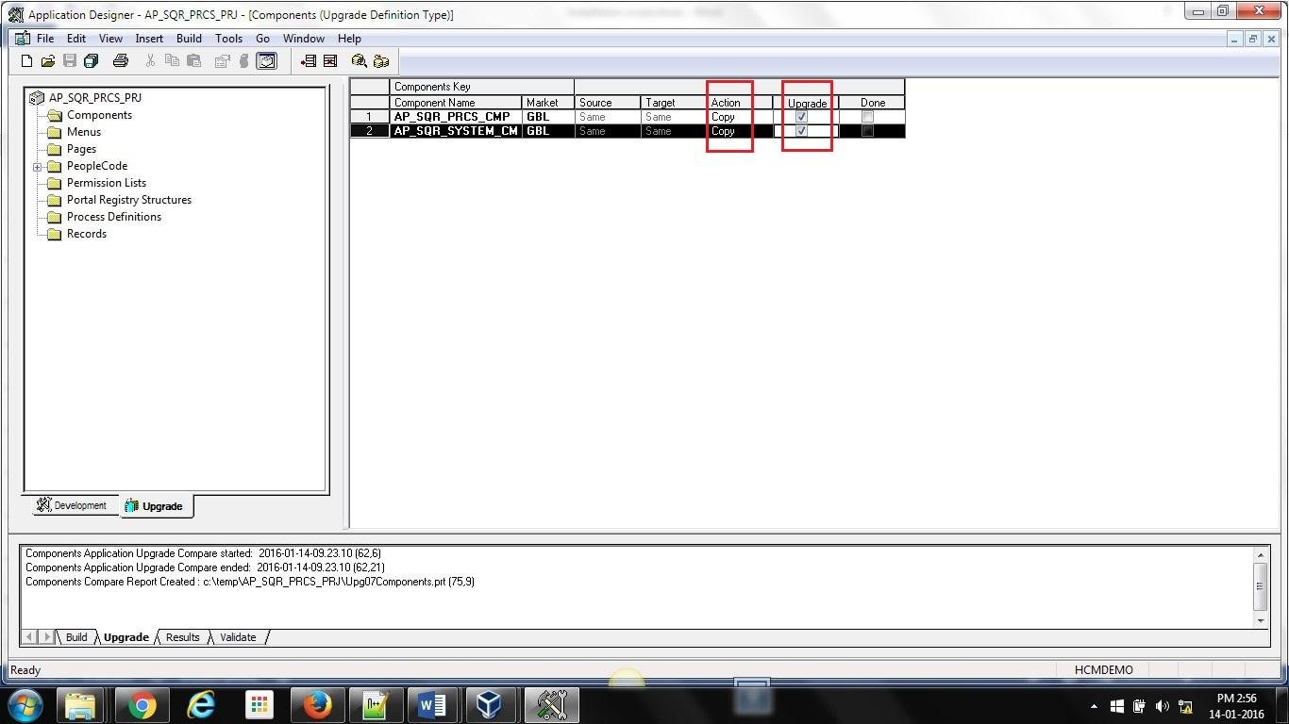

1. After you are satisfied with the Upgrade flags set, go to Tool > Copy Project > From File...

**Figure 9**

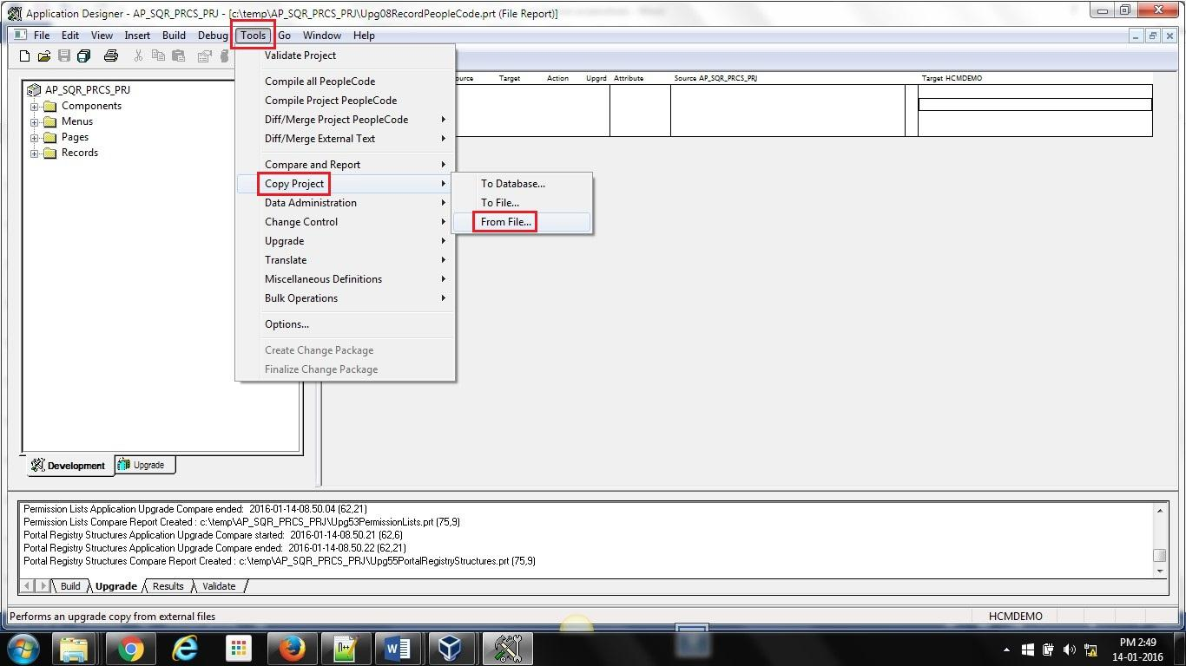

1. Choose the project folder extracted in step 2. Click *Select*.

**Figure 10**

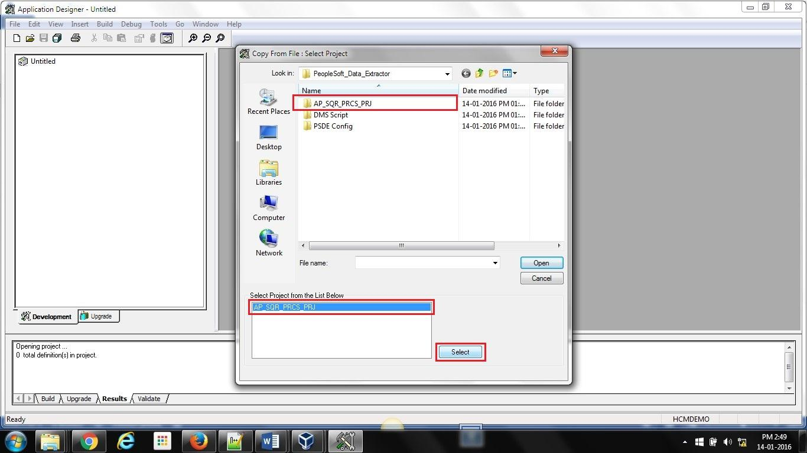

1. Click *Copy*

**Figure 11**

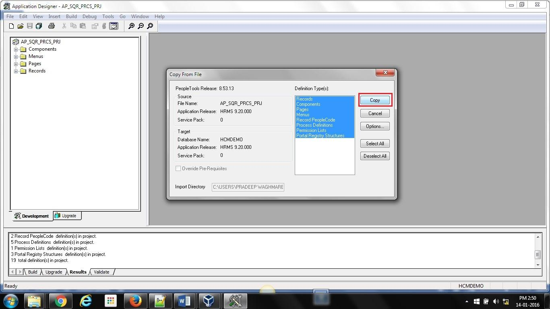

### Step-2: Build the tables

1. Go to Build > Project. Select “*Create Tables*” and *Execute and Build Script*

**Note**: If you plan to only build the script and then execute it later in SQL, then select “Build Script file” radio button. Please remember to execute the SQL script in database. Please change tablespace name in the script if needed.

**Figure 12**

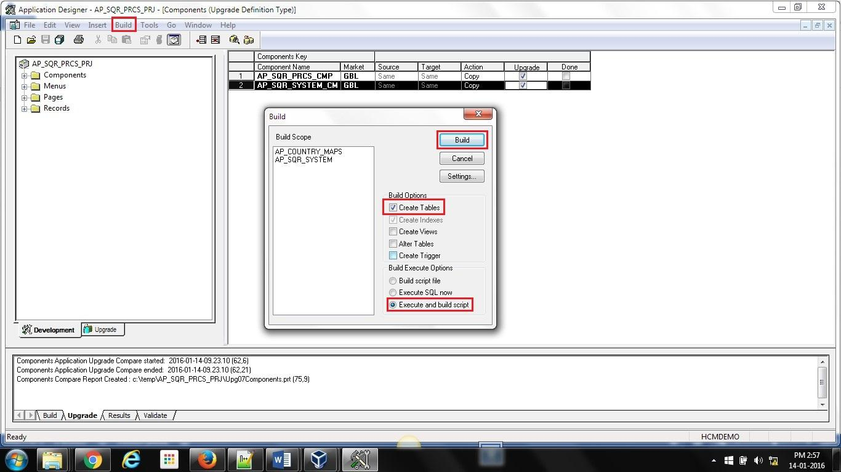

1. Check for any errors. Click *Close*.

**Figure 13**

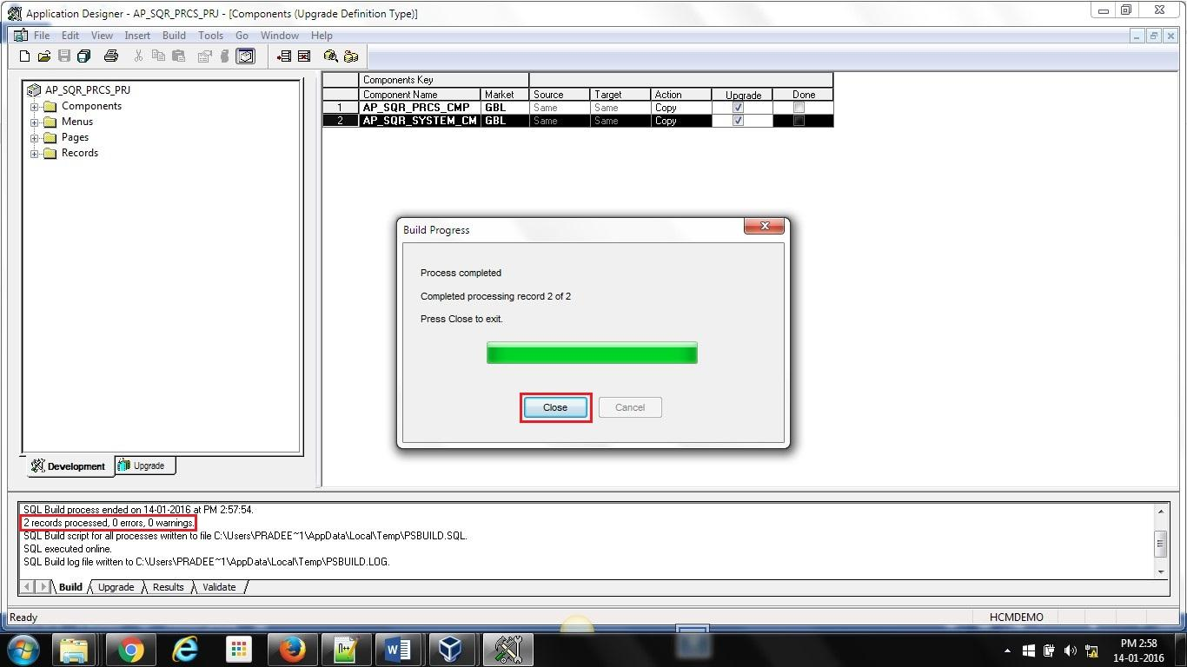

### Step-3: Run DMS import scripts

1. Copy the “*Import Script.dms*” and “*AP_SETUP_DATA.dat*” into C:\TEMP directory on your hard drive.

**Note**: If you plan to use any other directory, then remember to change the path in the import script accordingly.

1. Start Data Mover: Open Application Designer. Login using **PS Admin** credentials. Go to Go>Data Mover.

**Figure 14**

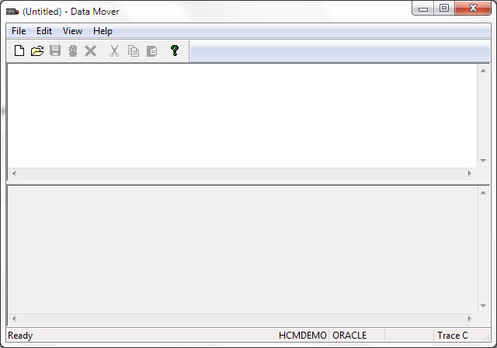

1. Open the DMS file from C:\TEMP directory into the DMS editor.

**Figure 15**

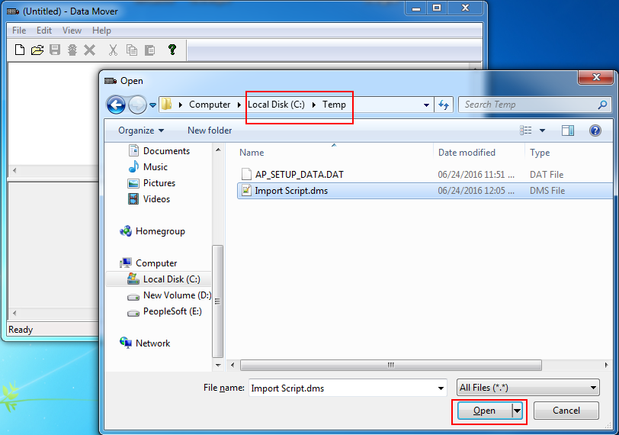

1. Run the DMS scripts by clicking the Run button. Verify the *Successful completion* status.

**Figure 16**

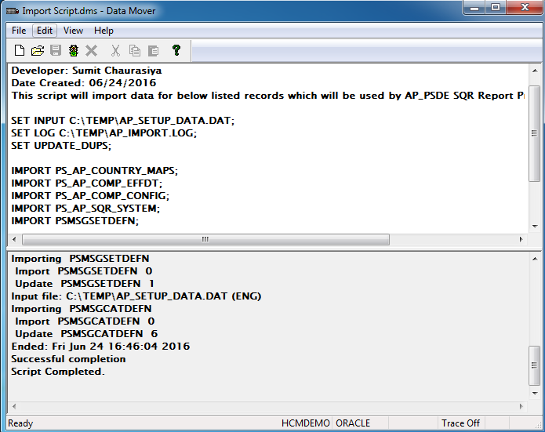

### Step-4: Clear the App Server and Web Server cache

1. Start PeopleSoft *PSADMIN.exe* utility for admin tasks
2. Refer instructions on how to clear the cache.

**Note**: You will need to login using **PS Admin** credentials to run the *psadmin* task

### Step-5: Copy SQR files in the PeopleSoft system SQR folder

1. Go to below path, you will find latest SQR/ SQC copy:

<https://drive.google.com/open?id=0B_8gN_ucZ8JydDBUOVBKdW44S0U>

Download these.

1. Place the SQR and SQCs in default SQR directory in PeopleSoft Servers.

### Step-6: Set the password for the output files

1. Start the PIA and login using the PS Admin credentials. Go to Main Menu > Appirio PeopleSoft SQR Process > Appirio Process Config > System tab. Overwrite the default password with your own password, Click the Save button. The default password is “workday1”

**Note**: This password will be used to open the output files. Please follow password guidelines on the same page. As a security measure, the output files will be generated ONLY when the password for the output files is set.

1. Go ahead and overwrite the default password with your own password. You will be prompted for the password when you try to open the output files.

**Figure 17**

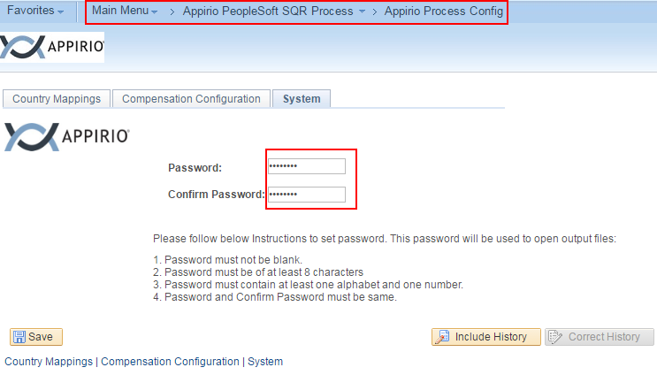

# Step by Step Instructions for using the system

## Running the SQR Process

1. *Go to Main Menu > Appirio PeopleSoft SQR Process > PeopleSoft Data Extractor*
2. Go to *Add a New Value* tab. Provide a *Run Control ID*. Click *Add* button.

**Figure 18**

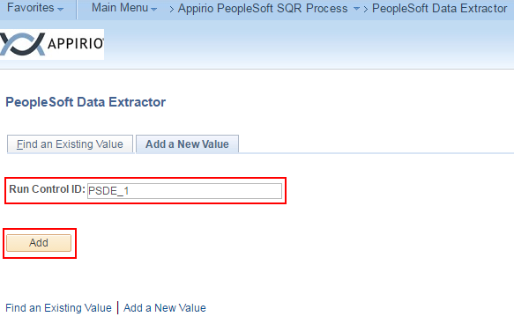

1. Select the name of data for which you want to generate the output file. Click *Run*. Process *PeopleSoft Data Extractor* is selected. Click *OK*.

**Note:** If user checks *Select All* check box, all the Check boxes will be checked and if he unchecks the *Select All* check box all the check box will be unchecked. Process will generate data for all the selected sheets. But header will be present for the sheets as per [Appirio standard data gathering workbook](https://docs.google.com/spreadsheets/d/1EMByVN_sxr_X3l12IGdo7L2-7BL6lNHTKfAqwWsCHT0/edit?usp=sharing).

**Figure 19**

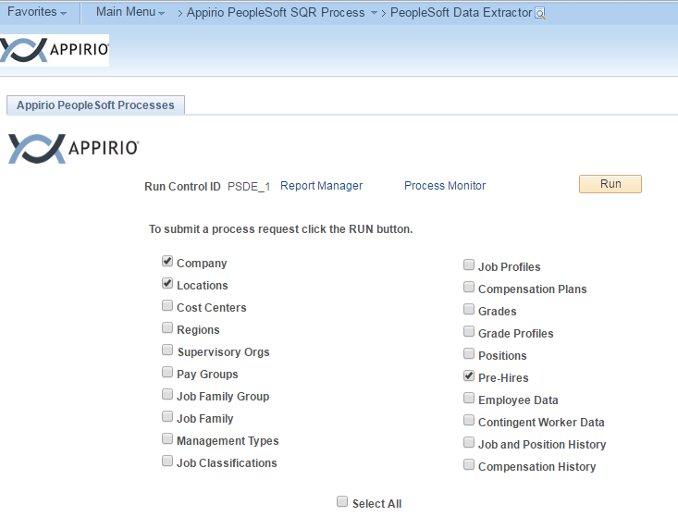

**Figure 20**

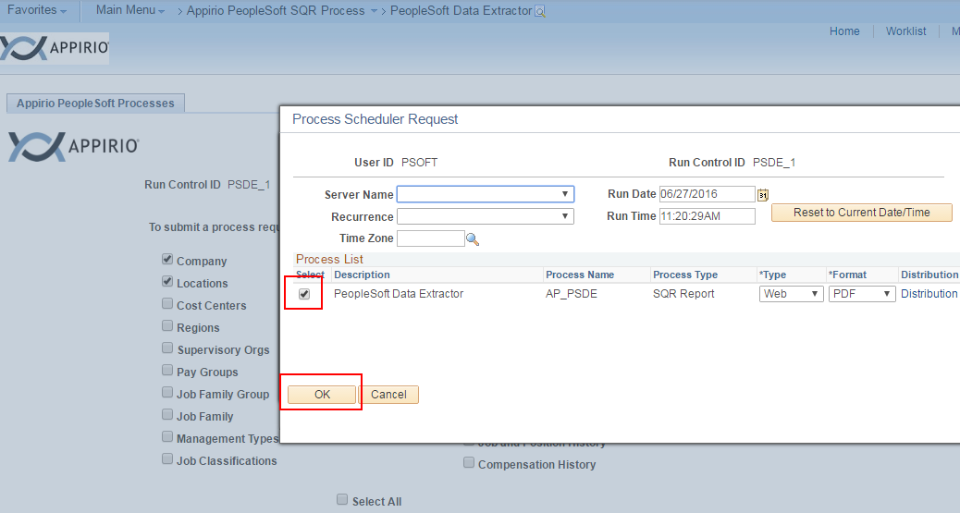

1. Click “*Process Monitor*” to check the process status. Click “*Details*” to see the logs and the output file generated once *Run status* changes to ***Success*** and *Distribution Status* changes to ***Posted***.

**Figure 21**

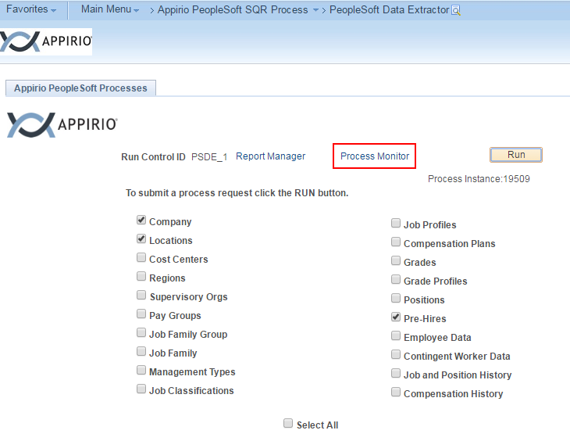

**Figure 22**

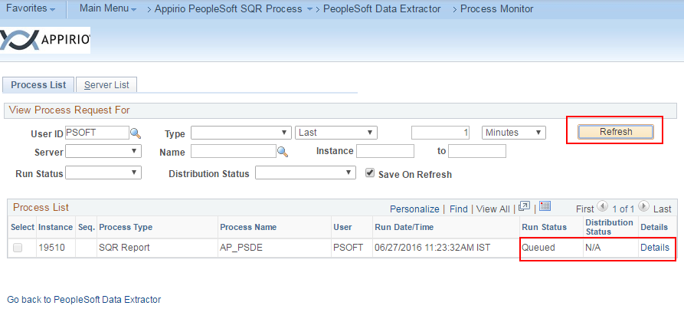

**Figure 23**

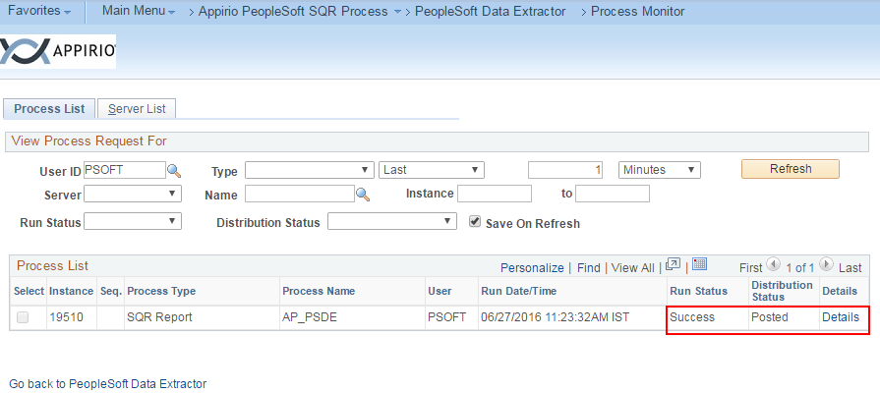

1. The *Process Detail* information screen

**Figure 24**

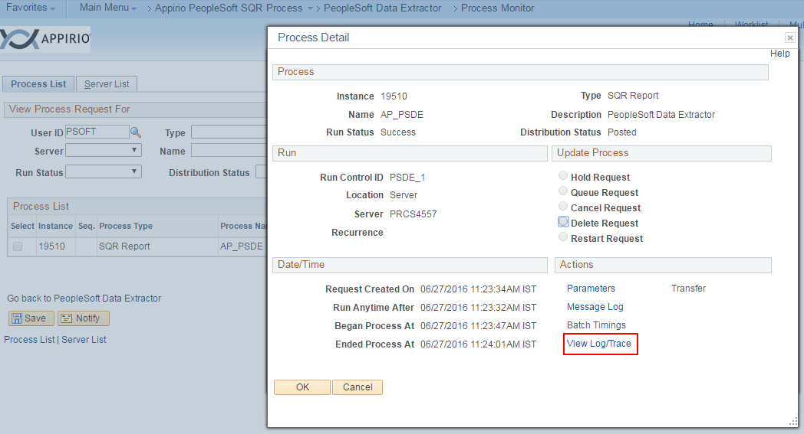

1. Click *View Log/Trace* link

**Figure 25**

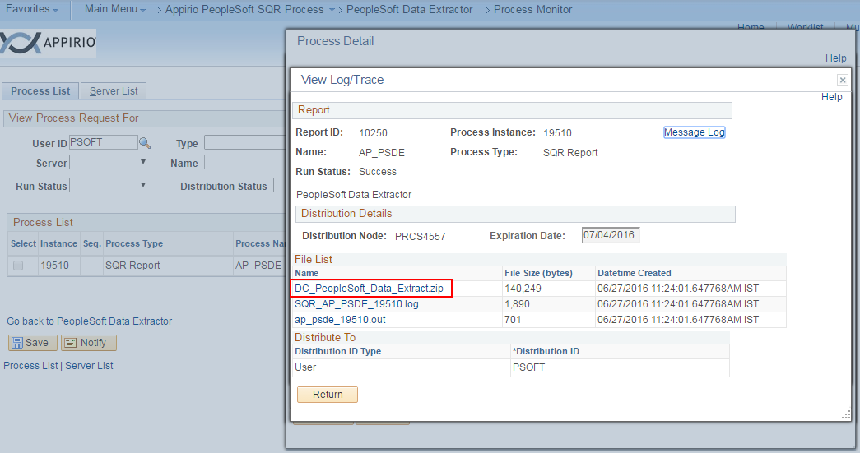

1. Click the ***DC_PeopleSoft_Data_Extract.zip*** filename and save the file in an accessible directory.

**Figure 26**

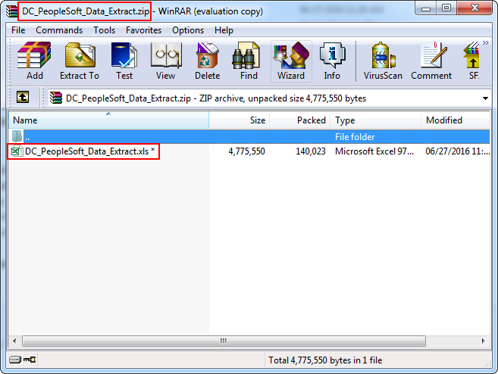

1. To open the file, please type in the exact password you had set in the *System* Config page.

**Figure 27**

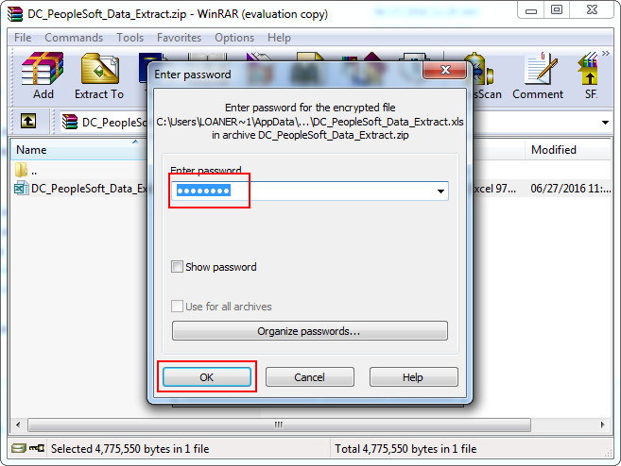

Output sheet will have links to go to particular Worksheet like Pre-hires, Locations, Company etc. Click on the link and find data.

**Figure 28**

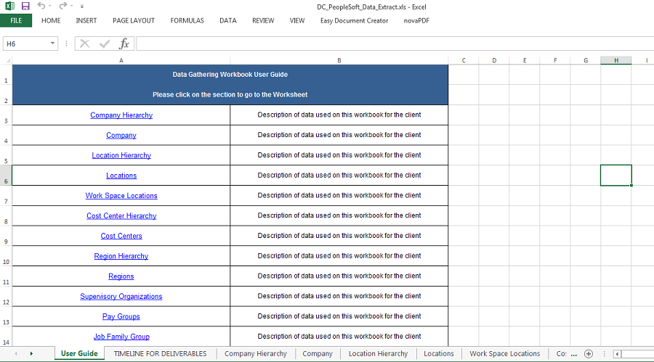

Click on ***Pre-hires***

**Figure 29**

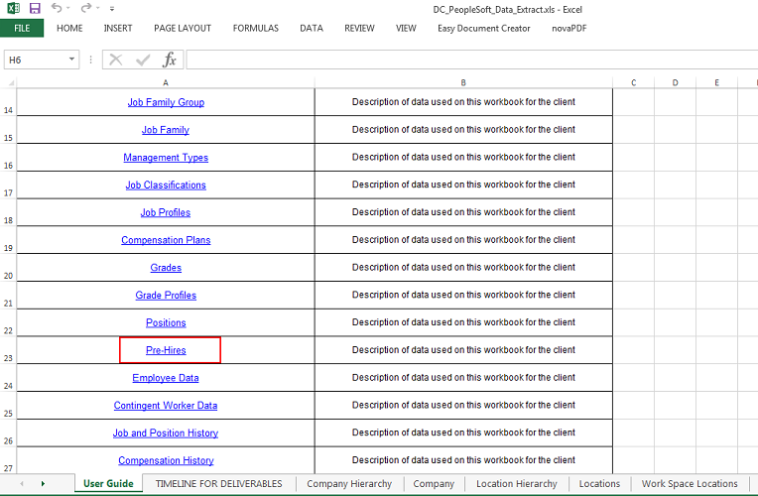

It will take us to ***Pre-hires*** Sheet. User may go back to User Guide sheet if you click on ***User Guide*** Link.

**Figure 30**

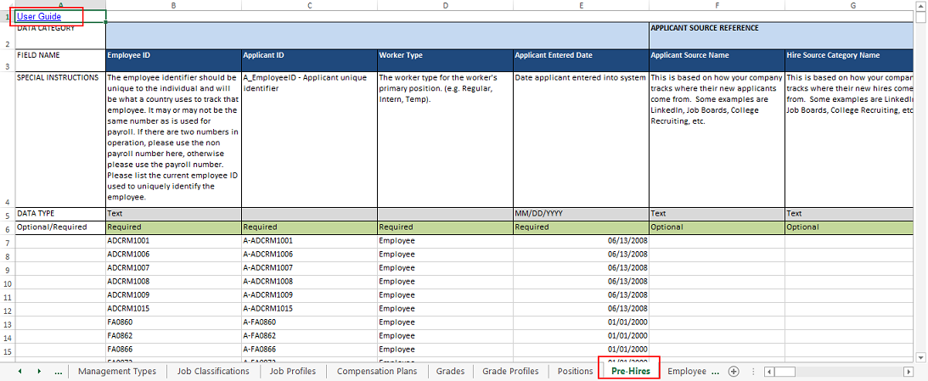

Similarly, user can find data for all the selected types in run control page and for others user will see only headers.

**Figure 31**

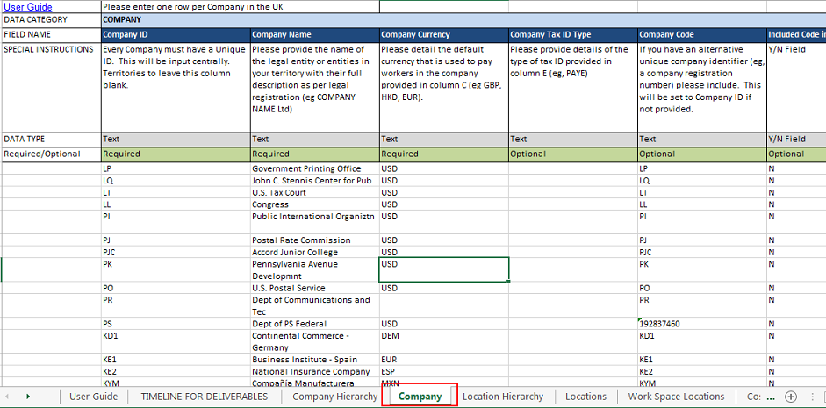

**Figure 32**

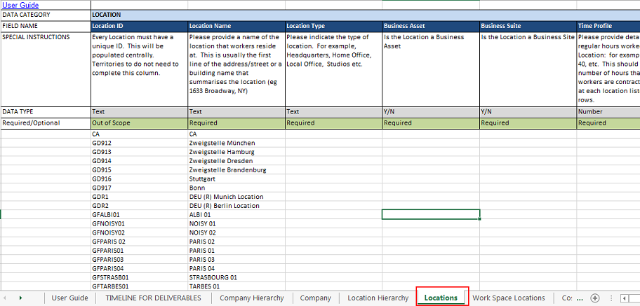

Only Headers will be created for unselected sheets.

**Figure 33**

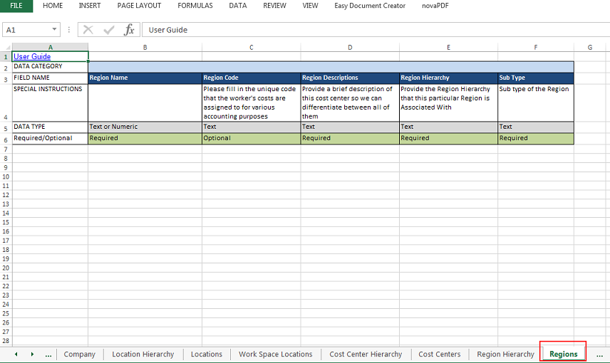

# Conventions

1. All customized PeopleSoft Object names begin with “AP”
2. All custom SQR/ SQC filenames begin with “ap_”
3. Object other than these are used as delivered by PeopleSoft.

# Errors, Malfunctions, and Emergencies

1. The new menu links for PeopleSoft Data Extractor are not visible

Resolution:

1. You will need to clear the App Server and Web Server cache for the new menu to be visible. Please refer cache clearing step above.
2. Please make sure that you login using the PS Admin credentials.
3. After running the SQR process, the file is not visible in the *View/Trace* Log.

Resolution:

You have not set the password for the output files. Please refer Step-6 above.

1. If user gets error for *STRINGSPACE* after running the process as below example:

**Figure 34**

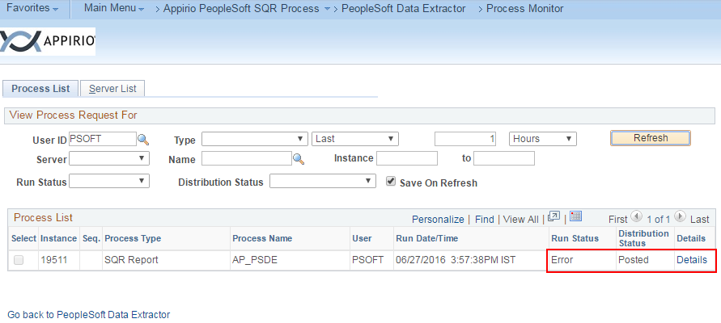

Resolution:

1. Review the .out file attached with process.

**Figure 35**

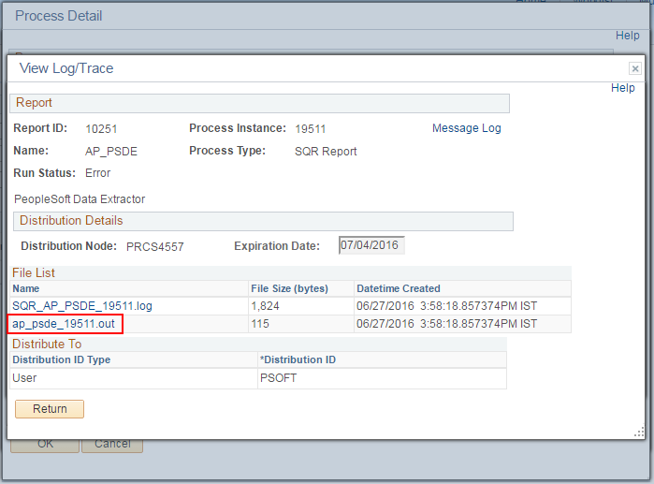

**Figure 36**

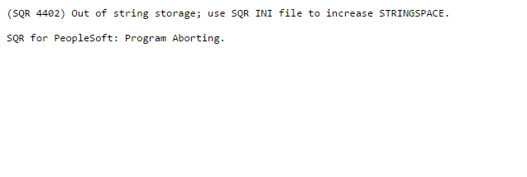

1. If user gets error as above then he needs to increase the *STRINGSPACE* limit mentioned in pssqr.unx (in case of Unix) or pssqr.ini (in case of Windows).

**Figure 37**

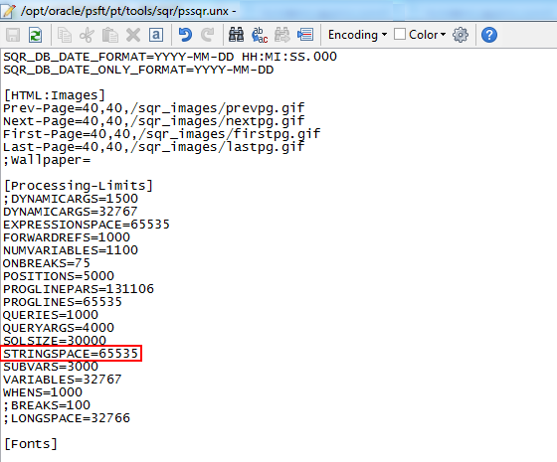

1. Increase the limit to 75000 and save it. Now rerun the process and won’t get same error.

**Figure 38**

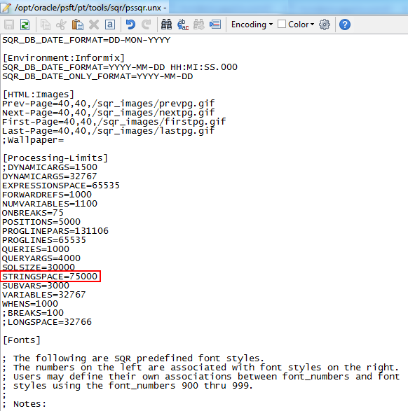



*If you encounter issues not addressed by this user guide, please contact below person for additional support.*

*Email: Rahul Jain <rahul.jain@appirio.com>*

# Messages

If there are any messages on pages or popup, list them down along with their meaning.

# Appendix A – Reference Documents

NA

# Appendix B – Glossary of Terms

*PeopleSoft Data Extractor*: This is the name given to the tool collectively containing the objects needed to perform the data extraction